Contents for the webpage:

About Us

Bapuji Rural Enlightenment and Development Society (BREDS) was established in 1983, with the goal to provide support to the most marginalized and vulnerable rural communities to elevate their socio-economic status through empowerment and sustainable livelihood promotion. BREDS firmly believes that building capacity in the communities is the only way to work through the poverty and create a significant change. BREDS underlying motive is to infuse the sense of ownership. Involving people at every level of decision-making within the programs to transform beneficiaries into participants, which will lead to inclusive development.

“Help the people to help themselves”

BREDS fundamental frameworks for programme interventions are based on Human- Centered methodology, which is solely based on participatory action research.

•Understanding, observing and contextualization of the problem and the community

•Community participation and brainstorming session with all the stakeholders to opt for best solution

•Building capacity and ownership in the community to scale-up sustainability

•Develop solutions rooted in communities’ needs and lifestyles for inclusive development.

OUR VISION

To realize the Gandhian dream of Gram Swaraj by building a network of autonomous village communities which are self-sufficient and self-reliant.

OUR MISSION

To capacitate the communities to become better informed and enlightened of their rights and choices in order to control the environment, resources and levels of power.

To strength then the institutional base necessary for social transformation and to bring positive change in the quality of life of marginalized communities.

Goal

To facilitate the process of empowerment of marginalized communities by reducing vulnerabilities and increasing capacities, and enabling them to liberate from oppression and exploitation and lead life with dignity and respect.

Objectives

-To infuse the sense of ownership to empower the community to increase the level of control over their lives and resources.

- To recognize and address the needs of the women for empowering and to promote gender equity.

-To protect and restore the local ecosystem for preserving natural resources.
- To provide easy and affordable financial solutions to low-income groups through promoting and strengthening Self Help Groups (SHGs) and Mutually Aided Cooperative Thrift Societies (MACTS).

-To promote agriculture as a viable livelihood option to improve food security and safety.

-To create resilient community to able to effectively respond, withstand, and recover from adverse situations and to reduce the harmful effects of all hazards.

Focus Areas

Urban poverty (with a focus of informal workers) and slum development
- The main focus is to reduce the insecurity and uncertainty of income and stabilize their livelihoods.
-Slum development through access to basic infrastructure- access to clean water, sanitation, housings etc.
- Access to benefits & entitlements to the informal workers under social security
- Awareness and exercising workers rights

Achievements:
- 3000 low skilled construction workers (1300 Female and 1700 Male) are organized under 5 societies to demand their rights and entitlements.
-400 women street vendors are registered under Street Vendors Act 2014.
-2 street vendors’ cooperatives have been promoted to provide affordable loans
-9 slum committees have been strengthened to ensure all basic amenities such as access to water, sanitation, power, land title deeds, functional aganwadi (pre-school), 100% coverage of anti- poverty schemes to all the inhabitants.
-Above 15,000 grievances have been addressed.

Gender-Based Violence and Enhancing Economic Empowerment of Women
-To encourage women actively participate in the community activities.
-Their needs are understood and ensure they are part of the project design
- Exercising women rights to prevent and Respond to Gender-based Violence
- Promoting women ownerships to promote women empowerment

Achievements:
-80 cases of gender-based violence have been identified and provided legal and counseling support

Financial Inclusion
-To encourage women to have access to financial resources
-To promote different livelihood ventures
-To inculcate the habit of thrift among women
-To capacitate their skills to establish MACTS

Achievements:
-18000 women are organized to form five cooperatives (2 in rural and 3 in urban area)
-20 women are employed in both cooperatives

Sustainable Livelihoods & Food Security

-Comprehensive and integrated approach to create sustainable livelihoods
-To control people migrating from rural areas to find better opportunities for livelihood, health, education for children
- To work with the rural communities to make agriculture a viable livelihood option and fight poverty.
- To secure Food & Nutrition security in the vulnerable community (Children, Women, Pregnant & Lactating mothers) through ensuring access to social security schemes.

Achievements:
- 113 villages including 1874 marginal farmer families have been benefitted
- Each family will get a minimum of 1 lakh profit from the yields
- Water and soil conservation activities are taken
- Community asset base is created
- Organic farming and horticulture

- 85 Toilets have been constructed at Savarabejii village
- 100% institution deliveries recorded
- 100% Immunization recorded
- 100% beneficiaries received THR (take Home ration- Supplementary nutrition) now under Anna Amrutha Hastham mothers and Lactates eating at Anganwadi center itself.
- school building inaugurated with all amenities (Electricity, Drinking water and Toilet) at Kapubejji village (Vandrai – worth of Rs. 1000000)
- 1 no. Anganwadi got sanctioned at Vandrai village (Worth of Rs. 5,00,000) with all amenities

Child Development

- to run and monitor 1098 child helpline to address the issues of child abuse, child labor and violation of child rights, with a vision to achieve a child friendly society
-to prevent child marriages, child labor and trafficking
-to identify the child issues, counsel and refer to different Government institutions
-to eliminate the child labor
-to enroll the identified children in government schools

Achievement

-115 School Dropout Children are re-enrolled in formal schools and Hostels.
- 27 Begging and Child Labor Rescued with the help of Police and Labor Department and provided shelter and education with the help of Community Welfare Centre
- 86 Child Marriages were stopped with the help of Child Marriage Prohibition Officer, Police and Community Welfare Centre.
- 7 Girls rescued from trafficking
- 4 Child Sexual Abuse Case- Provided Counseling to child and parents
-First Investigation Report (FIR) filed & Charge sheet against the employer- Rs 20000/- compensation provided to child form employer.

Resource Management, Environmental Protection & Climate Change
BREDS has undertaken Community Based Tank Management projects. The objective of the project is to increase the income level by improving agriculture livelihood support with focus on social and environment components and focused on Rain water conservation, Wasteland development, Uncultivable land brought in to cultivation, increased food security, soil & moisture conservation, preservation of ground water.

Where we work
BREDS has been working in north Andhra region and boarding villages of Odisha.

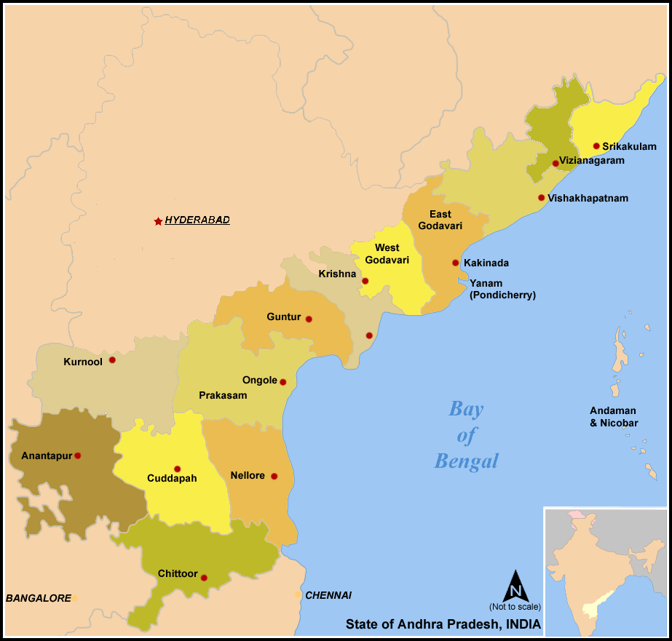

Our partners
- The Bread for the World, Germany
- DiakonieKatastrophenHilfe, Germany
- NABARD, Hyderabad
- Child line India Foundation, Mumbai.
- Indo-Global Social Service Society, New Delhi.
- CARE INDIA
- Welt Hunger Hilfe (German Agro Action)
- BD
- Action Aid
- Water Sanitation for Urban Poor
- Grant for Grassroots People, Japan Consulate
- Centurion University, Orissa India for development study and research.
- Gram Tarang Employability Training Services (GTETS), Bhubaneswar, for skill development and placement of adolescents, youth and school dropouts.
- Gram Tarang Inclusive Development Services (GTIDS), Visakhapatnam, for Financial Inclusion.
- Government of Andhra Pradesh (APCBTMP)
- Business Correspondence program, Andhra Bank- Govt. of AP
- Dr. Sangeeta Prasad & Mr. Adam (USA)
- Dr. Prasad & Dr. Jayalaxmi (USA)
- Dr. Rajeev & Dr. Vyju (USA)
- Mrs. Vijaylaxmi Kakarala ( Kakarala Foundation)

Projects Undertaken:

- Empowerment of Urban Vulnerable Communities in Visakhapatnam Municipal Area
- Addressing The Vulnerability Of Domestic Workers Towards Inclusive Growth
- Micro Planning Workbook project led by WSUP Advisory India (Water & Sanitation for Urban Poor) under the Ministry of Urban Development, a USAID funded program" Capacity Building for Swachh Bharat Mission
- Emergency Response to cyclone HUDHUD- CARE India
- Technical Consultant for Society for Elimination of Rural Poverty
- Suraksha (Food& Nutrition) Network Project- BREAD FOR THE WORLD
- Andhra Pradesh Community Based Tank Management Project (GIZ)
- MAA THOTA-National Bank for Agriculture and Rural Development (NABARD)
- The Child Rights and Child Protection- Child-line Project (Child-line Foundation)
- Saagarakiranalu - BREAD FOR THE WORLD
- Relief-Community Livelihood Resilience and Humanitarian Assistance in Phailian and Flood affected Areas of Orissa and AP- Indo Global Social Service Society
- Subhodayam
- Swashakti
- Subha Sankalpam - a Good Determination of SOUL Project (Sustainable opportunity for up-liftment of livelihoods) - Indo Global Social Service Society

